CS 255 System Design Document Template

This template lays out all the different sections that you need to complete for Project Two. Each section has guidance to prompt your thinking. You will need to continually reference the interview transcript as you work to make sure that you are addressing your client’s needs. There is no required length for the final document. Instead the goal is to complete each section based on what your client’s needs are. Remove this note when you are finished, and replace all bracketed text with the relevant information.

UML Diagrams

UML Use Case Diagram
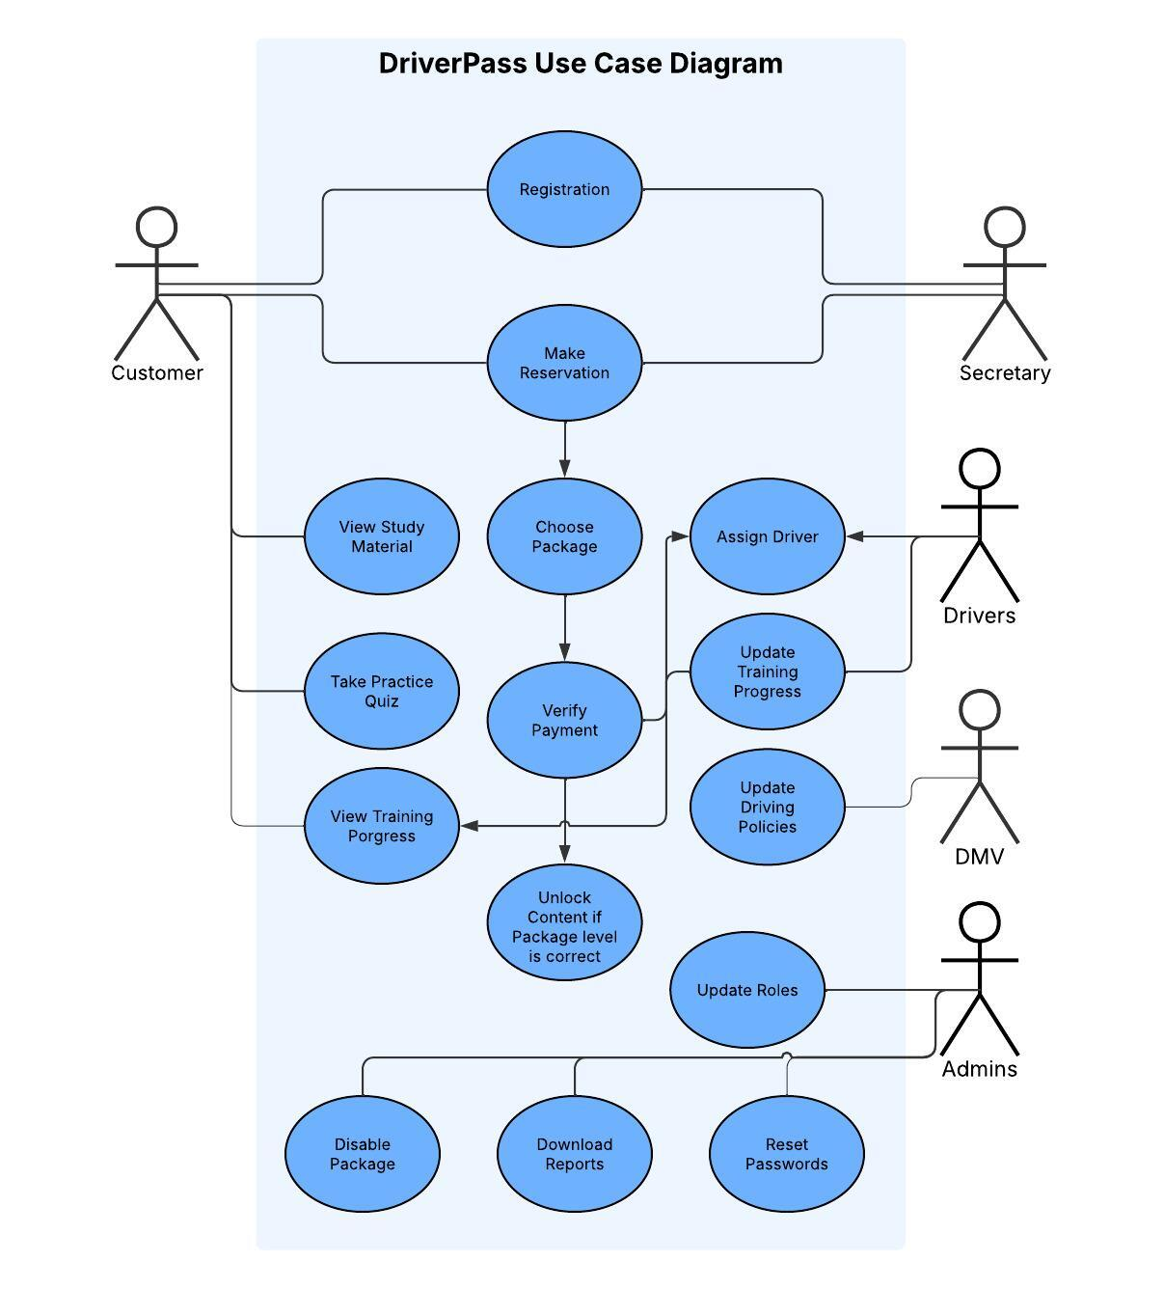

UML Activity Diagrams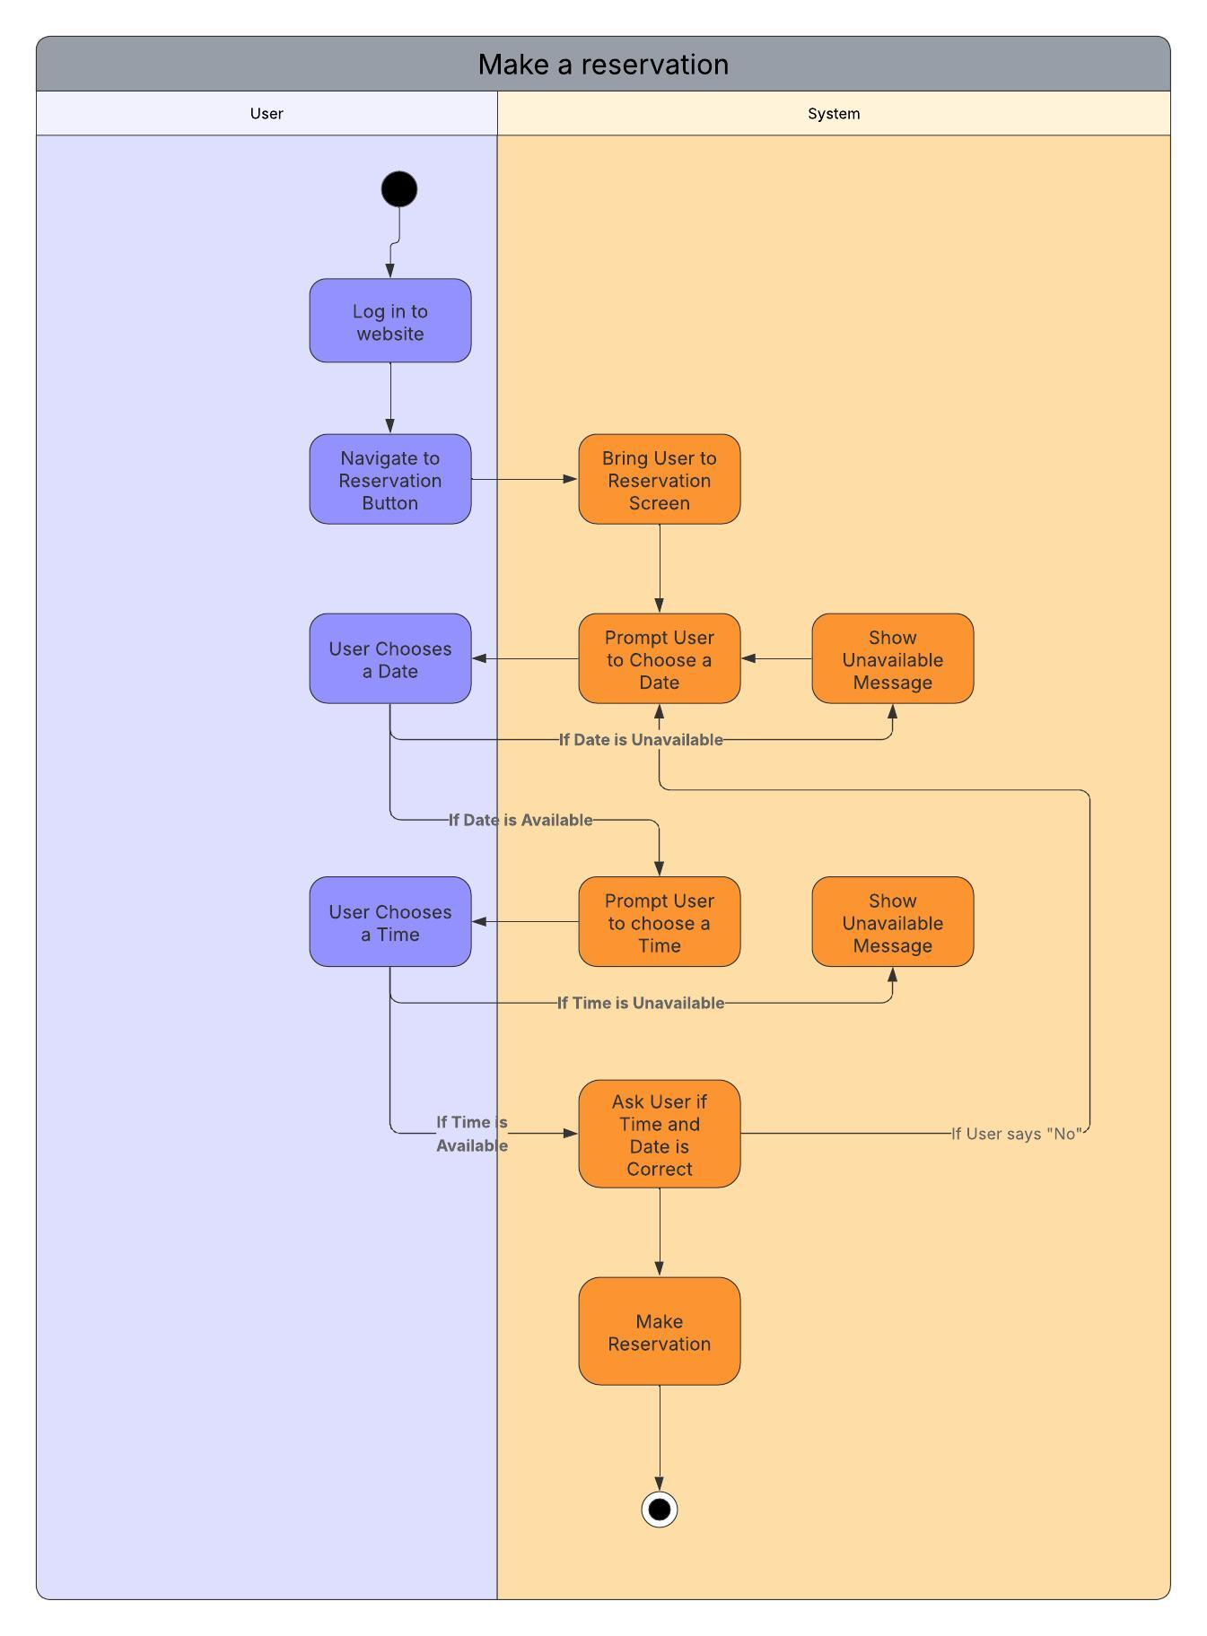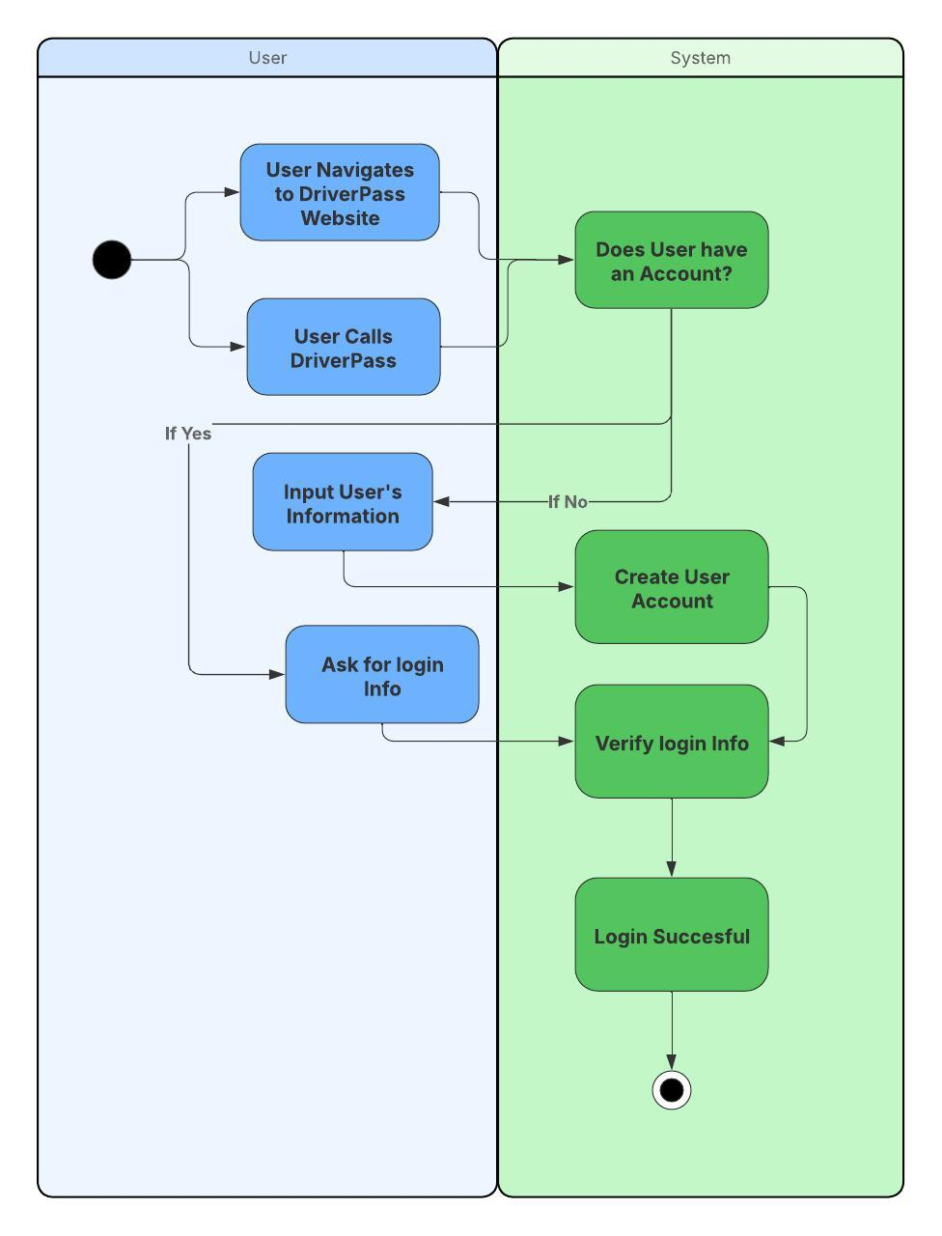

UML Sequence Diagram
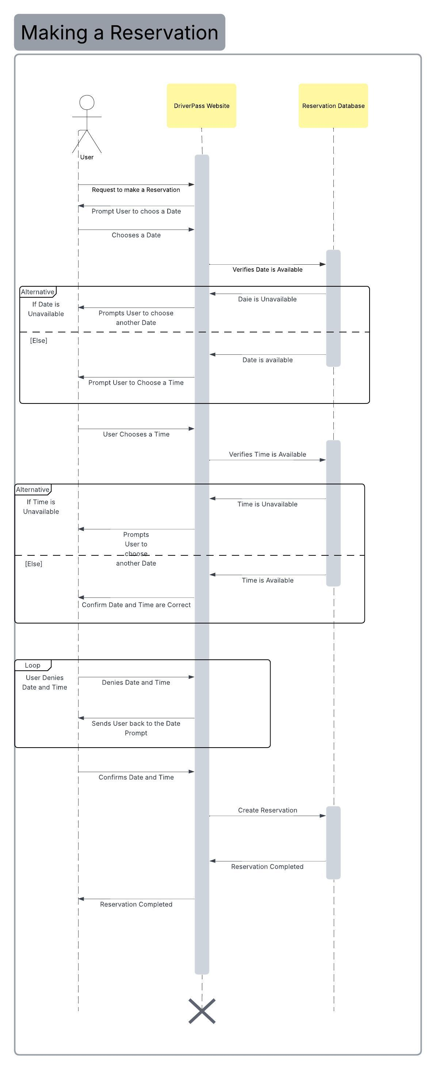

UML Class Diagram
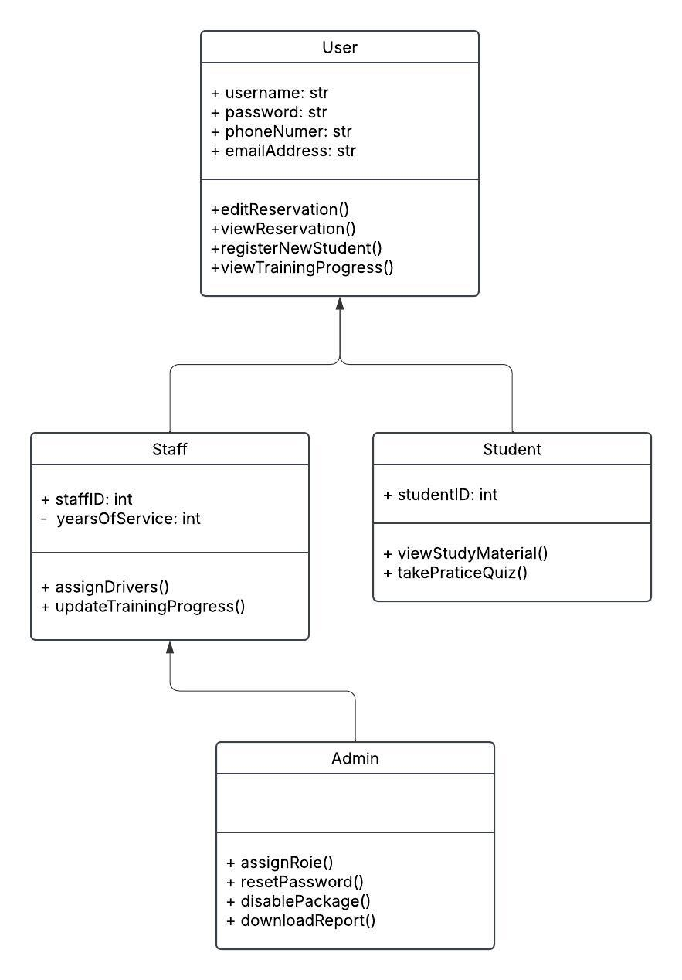

Technical Requirements
Hardware Requirements:
- Cloud-based Server
- Internet Connection
- Computers
- Power Source
- Phones
- Network Servers
Software Requirements:
- System available on common platforms
- Run on Company Operating System
Tool Requirements:
- Computer with Programming Software
- Network Administration Tools
Client Requirements:
- Device with Internet Connection
- Internet Connection
- Web Browser Application

